**EXPERIMENT 1** :- THRESHOLD FREQUENCY = 45

--------------- **RAINFALL NORMALISED | LINEAR KERNEL FUNCTION**  ---------------

|  |  |  |  |
| --- | --- | --- | --- |
| **INPUT** | | **MODEL** | |
| TRAINING SET | INSTANCES FROM 1 TO 3904 OF EXTMAT2 | SUPPORT VECTOR MACHINE REGRESSION MODEL | |
| TARGET FOR THE TRAINING SET | INSTANCES FROM 2 TO 3905 OF rain_mum_1969_2007_1grid_norm | TRAINING | * mdl1_2 = fitrsvm(X1_2,Y1) * Trained using the predictor values in the matrix X1_2 and the response values in the vector Y1 * X1_2[3904 x 1010]=instances from 1 to 3904 of EXTMAT2 * Y1[3904 x 1]=instances from 2 to 3905 of rain_mum_1969_2007_1grid_norm |
| TEST SET | INSTANCES FROM 3905 TO 4757 OF EXTMAT2 | PREDICTING | * yfit1_2 = predict(mdl1_2,Xp1_2) * Xp1_2 is the Test set * Xp1_2[853 x 1010]=instances from 3905 to 4757 of EXTMAT2 |
| TARGET FOR THE TEST SET | INSTANCES FROM 3906 TO 4758 OF rain_mum_1969_2007_1grid_norm | TESTING | * err1_2= immse(yfit1_2,Yp1) = **0.0109** * err1_2 is the Mean Square Error * yfit1_2[853 x 1]=predicted values on the Test set * Yp1[853 x 1]=instances from 3906 to 4758 of rain_mum_1969_2007_1grid_norm |

PLOTTING : plot(yfit1_2,'r')

hold on;

plot(Yp1,'g')

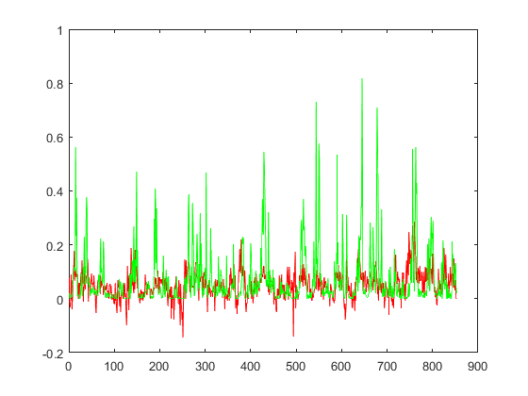

--------------- **RAINFALL NORMALISED | GAUSSIAN KERNEL FUNCTION**  ---------------

|  |  |  |  |
| --- | --- | --- | --- |
| **INPUT** | | **MODEL** | |
| TRAINING SET | INSTANCES FROM 1 TO 3904 OF EXTMAT2 | SUPPORT VECTOR MACHINE REGRESSION MODEL | |
| TARGET FOR THE TRAINING SET | INSTANCES FROM 2 TO 3905 OF rain_mum_1969_2007_1grid_norm | TRAINING | * mdl2_2 = fitrsvm(X1_2,Y1,’KernelFunction’,’gaussian’) * Trained using the predictor values in the matrix X1_2 and the response values in the vector Y1 * X1_2[3904 x 1010]=instances from 1 to 3904 of EXTMAT2 * Y1[3904 x 1]=instances from 2 to 3905 of rain_mum_1969_2007_1grid_norm |
| TEST SET | INSTANCES FROM 3905 TO 4757 OF EXTMAT2 | PREDICTING | * yfit2_2 = predict(mdl2_2,Xp1_2) * Xp1_2 is the Test set * Xp1_2[853 x 1010]=instances from 3905 to 4757 of EXTMAT2 |
| TARGET FOR THE TEST SET | INSTANCES FROM 3906 TO 4758 OF rain_mum_1969_2007_1grid_norm | TESTING | * err2_2= immse(yfit2_2,Yp1) = **0.0122** * err2_2 is the Mean Square Error * yfit2_2[853 x 1]=predicted values on the Test set * Yp1[853 x 1]=instances from 3906 to 4758 of rain_mum_1969_2007_1grid_norm |

PLOTTING : plot(yfit2_2,'r')

hold on;

plot(Yp1,'g')

